Name: Emmanuelle Isis Mbeugmo Manekeu

Assignment 3 – Performance measurements

Instructions
- Fill out your computer PC specs
- To perform a single assessment:
  - Identify a problematic view (ex: low FPS)
  - Record performance metrics when the camera is in that view specifically
  - Identify the source of the issue and the bottleneck
  - Perform an optimization technique to address the issue identified
  - Record the metrics again, after the optimization. Note the performance gain.
- Once you completed one assessment, you can perform another one on a different view or using a different optimization technique. Repeat until you obtain an acceptable performance.

Context of the assessment
Write your PC specifications here:
Type | Detailed Specs – be as specific as possible
GPU (integrated) | Intel® Iris ® Xe Graphics
GPU (dedicated)  specify your available memory | None
CPU | 12th Gen Intel® Core ™ i7-1255U
Memory (RAM) | 116.0 GB DDR4
Storage  Specify free space available | SAMSUNG MZVL41T0HBLB-00BH1 SSD (NVMe)  Capacity: 954 GB  Free Space: 498 GB free of 952 GB
Display resolution | 1920 x 1080

You only have to fill this section once.

Performance assessment #1

Performance Metrics
Type | Measured
Viewpoint screenshot  - Maximize your game  - Take a full screenshot (print screen) | 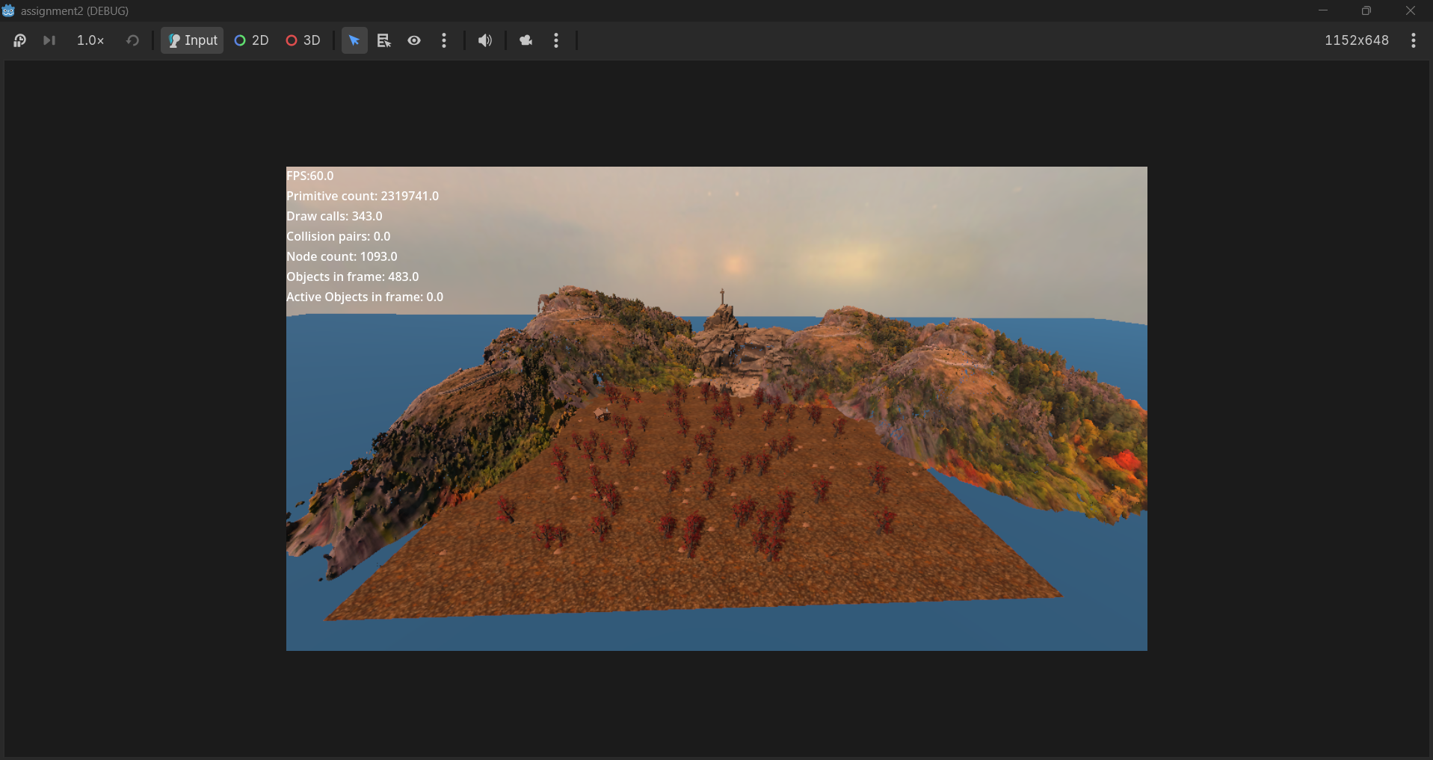
Viewport dimensions  (width x height, at runtime) | 1152 x 648
Frames per second (FPS) | 16 FPS
CPU Time (ms) | 25.96 ms
GPU Time (ms) | 42.57 ms
# objects | 3298
# primitives | 14640388
# draw calls | 686
# particle system visible | 1
# light emitters in view | 4
# of physics active objects in scene (requires runtime)* | 0
# of collision pairs in view in scene (requires runtime)* | 0
Git commit hash  Save your current scene in version control | 70daea01ab30fa2e149b03338134b14d80e777aa
*See performance_tracker.gd for help

Identification of the issue
Limiting resource  CPU or GPU | CPU | GPU
Bottleneck issue identified  Explain what you assessed as the main bottleneck and priority to solve | The primary bottleneck is an excessively high primitive count, approximately 14.6 million primitives, and heavy draw calls (686) overwhelming the integrated GPU. This causes the frame time to spike, hence, dropping the frame rate to around 16 FPS. Our priority is to increase the FPS and drop the counts.
Technique used to detect the bottleneck  Ex: Profiler, Visual Profiler, Debugging, Binary search, Hypothesis testing, etc. | Visual Profiler, Monitors tab and performance_tracker.gd script.

Optimization technique
Optimization technique used to increase the performance
Ex: LOD, Visibility Ranges, Occlusion Culling, Lowering textures quality, Lowering mesh details, Disabling shadows, etc.
Explain the technique used and how it was applied.
To reduce the massive rendering load on the integrated GPU, Occlusion Culling was enabled to prevent rendering complex 3D meshes and props. Additionally, Visibility Ranges were configured on distant background elements like the far-off meshes. This reduces the rasterization workload, dropping active primitives and draw calls per frame.

Gained performance
Explain briefly the increase in performance gained after the optimization was made. The gain should be measurable and quantitative. Ex: average FPS changed from 35 to 50

By successfully implementing occlusion culling over the indoor scene and removing inefficient visibility ranges, the GPU workload was streamlined. This helped raised the frame rate from 16 to 23 FPS.

Performance assessment #2

Performance Metrics
Type | Measured
Viewpoint screenshot
- Maximize your game
- Take a full screenshot (print screen)

Viewport dimensions  (width x height, at runtime) | 1152 x 648
Frames per second (FPS) | 23 FPS
CPU Time (ms) | 22.98 ms
GPU Time (ms) | 45.38 ms
# objects | 3298
# primitives | 13396011
# draw calls | 532
# particle system visible | 1
# light emitters in view | 4
# of physics active objects in scene (requires runtime)* | 0
# of collision pairs in view in scene (requires runtime)* | 0
Git commit hash  Save your current scene in version control | e42975b56df105e98d3964c2de75efbca55e4cce
*See performance_tracker.gd for help

Identification of the issue
Limiting resource  CPU or GPU | CPU | GPU
Bottleneck issue identified  Explain what you assessed as the main bottleneck and priority to solve | The primary bottleneck is heavy GPU-bound fragment shading. While the first optimization reduced the object count, and increased the frame rate, the integrated GPU is still spending 45.38 ms per frame on the viewport. This issue is caused by the real-time lighting and shadows (they account for 25.14 ms over 55% of our entire GPU rendering). Our top priority is reducing this heavy real-time lighting and shadow overhead.
Technique used to detect the bottleneck  Ex: Profiler, Visual Profiler, Debugging, Binary search, Hypothesis testing, etc. | Profiler, Visual Profiler and performance_tracker.gd script.

Optimization technique
Optimization technique used to increase the performance
Ex: LOD, Visibility Ranges, Occlusion Culling, Lowering textures quality, Lowering mesh details, Disabling shadows, etc.
Explain the technique used and how it was applied.
To target the lighting bottleneck, we will reduce the number of active Omnilight3D nodes (reduce their ranges and energy). Also, reduce the real-time shadows to stop the GPU from calculating expensive shadow-depth maps every frame.

Gained performance
Explain briefly the increase in performance gained after the optimization was made.

By changing the directional light modes, adjusting the shadow max distance, and tuning the shadow bias, I significantly lowered the heavy GPU shading and depth rendering overhead. This optimization dropped the GPU rendering time from 45.38 ms to 19.05 ms. Which boosted the frame rate from 23 FPS to 30 FPS.

Performance assessment #3

Performance Metrics
Type | Measured
Viewpoint screenshot
- Maximize your game
- Take a full screenshot (print screen)

Viewport dimensions  (width x height, at runtime) | 1152 x 648
Frames per second (FPS) | 30 FPS
CPU Time (ms) | 2.25 ms
GPU Time (ms) | 19.05 ms
# objects | 3298
# primitives | 6215720
# draw calls | 430
# particle system visible | 1
# light emitters in view | 4
# of physics active objects in scene (requires runtime)* | 0
# of collision pairs in view in scene (requires runtime)* | 0
Git commit hash  Save your current scene in version control | aca180143aee2f416d084725bcd5ec4924bad4d1
*See performance_tracker.gd for help

Identification of the issue
Limiting resource  CPU or GPU | CPU | GPU
Bottleneck issue identified  Explain what you assessed as the main bottleneck and priority to solve | The primary bottleneck remains GPU rasterization. Even after optimizing light and shadows, the integrated GPU is still processing over 6 million primitives at a 30 FPS cap. The priority is to reduce the active primitive density of complex meshes as they appear further away from the camera.
Technique used to detect the bottleneck  Ex: Profiler, Visual Profiler, Debugging, Binary search, Hypothesis testing, etc. | Visual Profiler, performance_tracker.gd

Optimization technique
Optimization technique used to increase the performance
Ex: LOD, Visibility Ranges, Occlusion Culling, Lowering textures quality, Lowering mesh details, Disabling shadows, etc.
Explain the technique used and how it was applied.
I implemented the Mesh LOD settings across background assets and lowered mesh details for distant environmental assets. By adjusting the global mesh LOD threshold in Godot, models far away from the camera were swapped for simplified geometry.

Gained performance
Explain briefly the increase in performance gained after the optimization was made.

By applying Mesh LOD to reduce distant polygon complexity, the rasterization workload on the GPU was simplified. This optimization dropped the primitives from 6215720.0 to 5320961.0. Eventually, this optimization enabled the GPU time to drop up to 18.42 ms, the CPU to 2.01 ms and the Frame rate up to 45 FPS

